Auto Updatable release steps:
- Vision.Console -> Right Click -> Properties
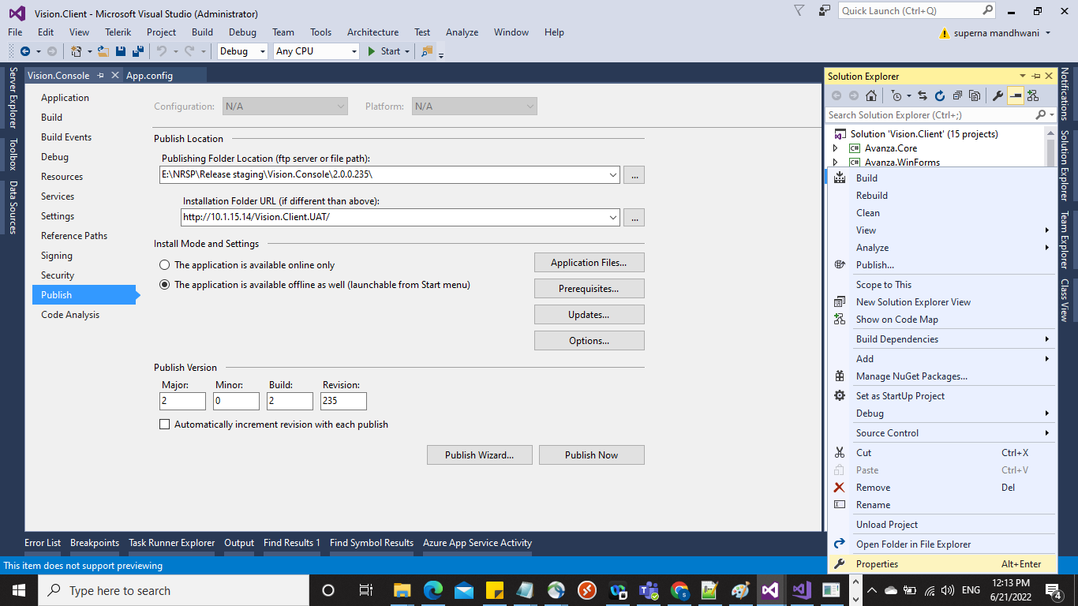

- Application
- In Assembly Information -> Specify the new version (Assembly Version, File Version)
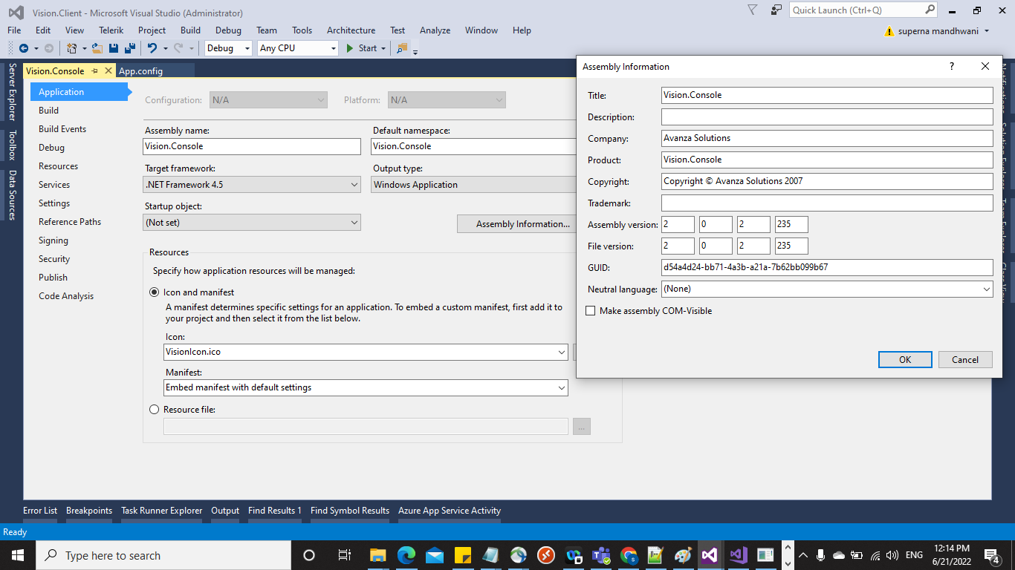

- Signing,
- Unable “Sign the ClickOnce manifests”
- Create test Certificate
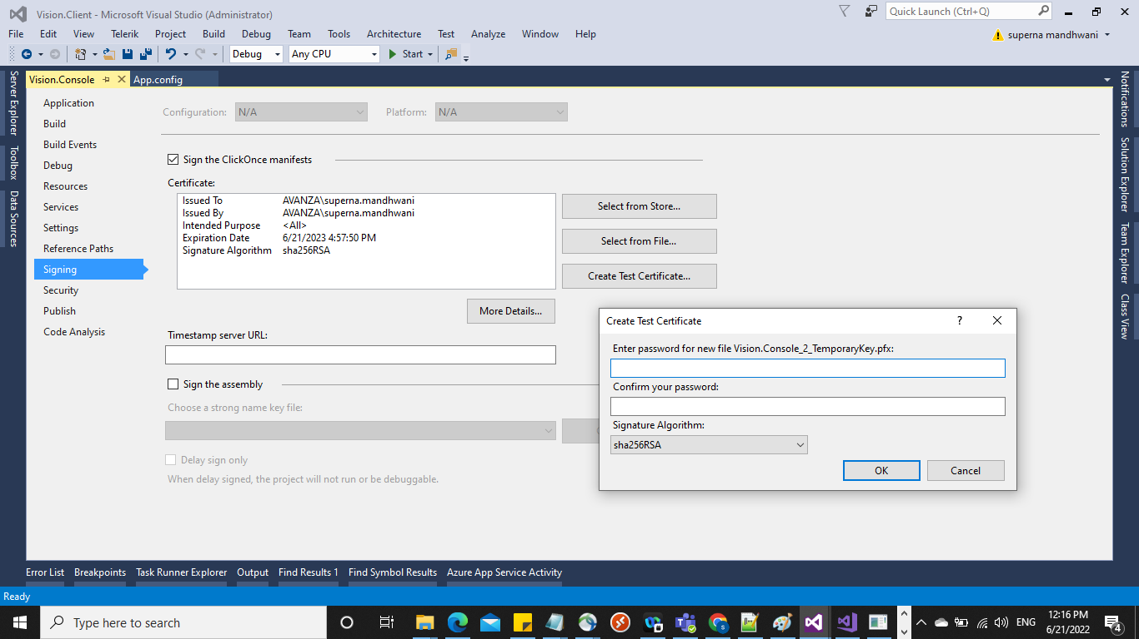

- Security
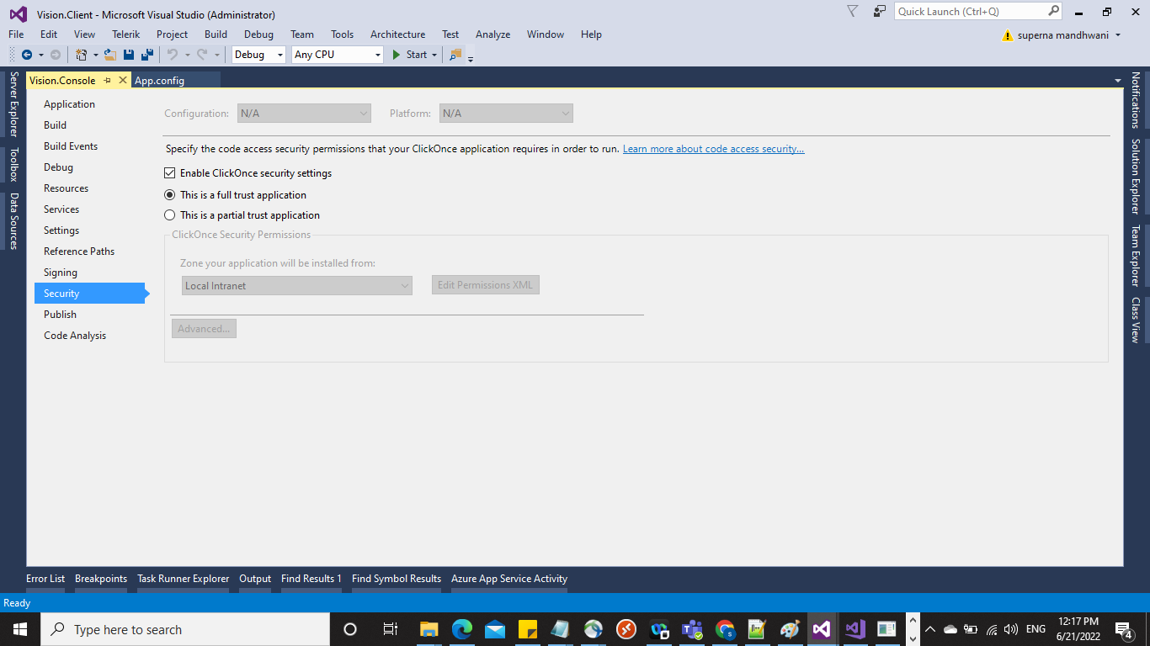

- Publish
- Give Updatabale URL
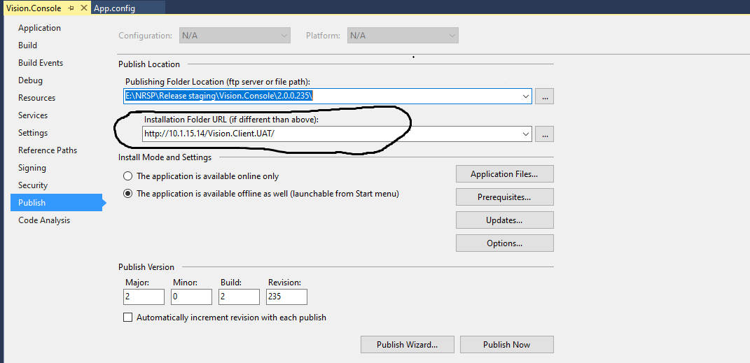
- Specify Publish version
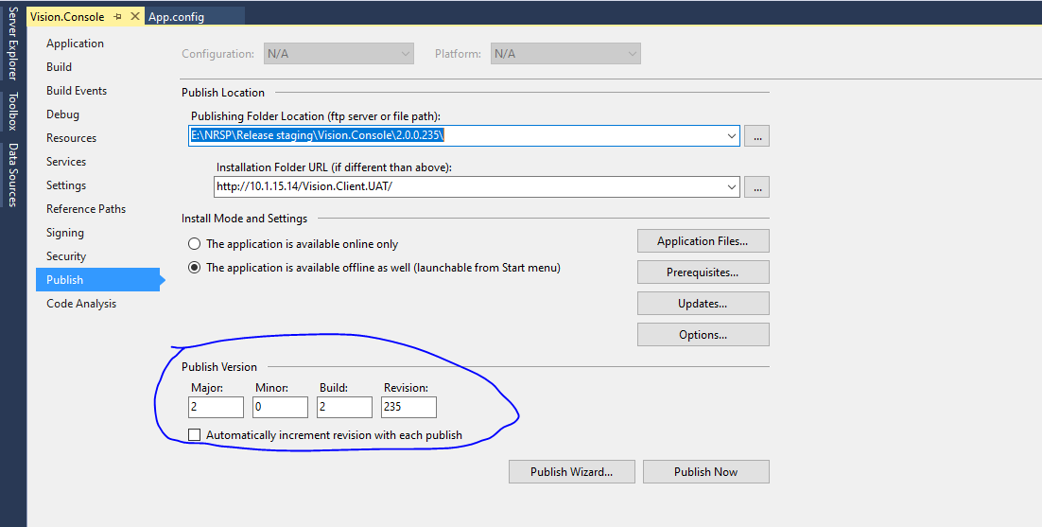

- Click on Updates Button
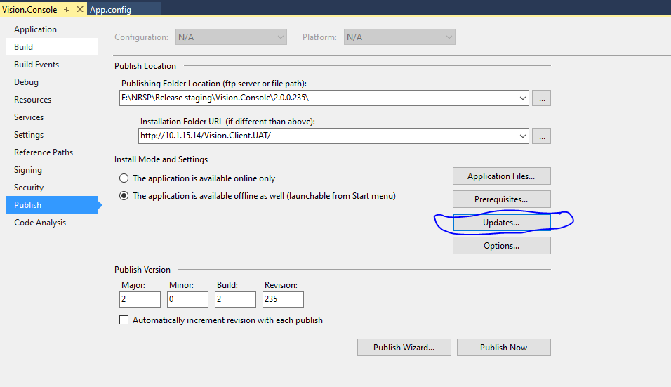
- Specify Version
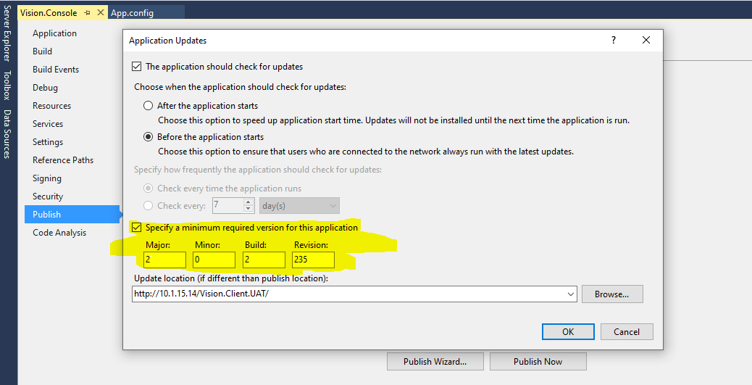
- Give Updatabale URL
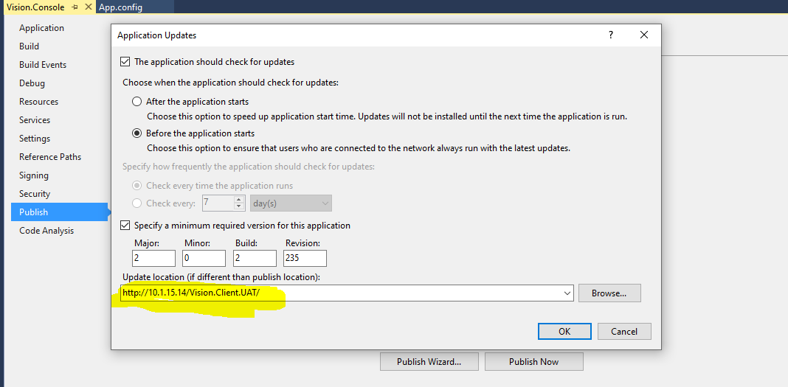
- Check on Update Before Run
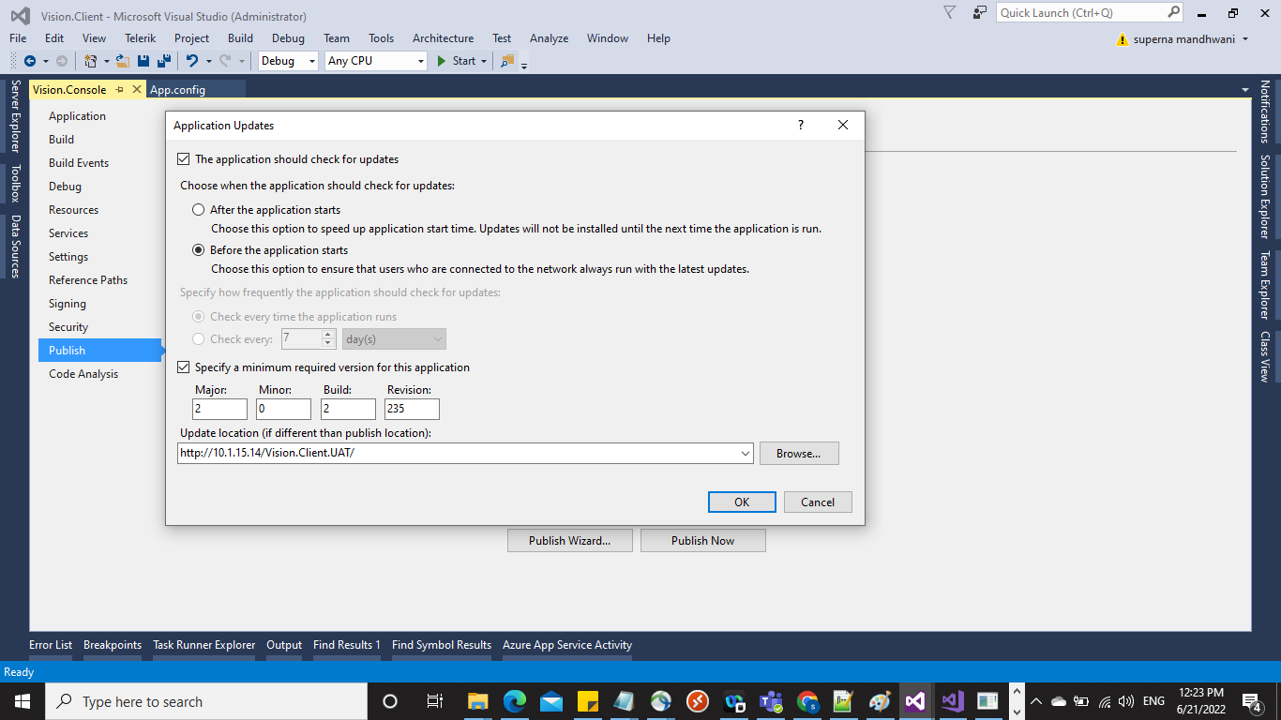

- Click on Options
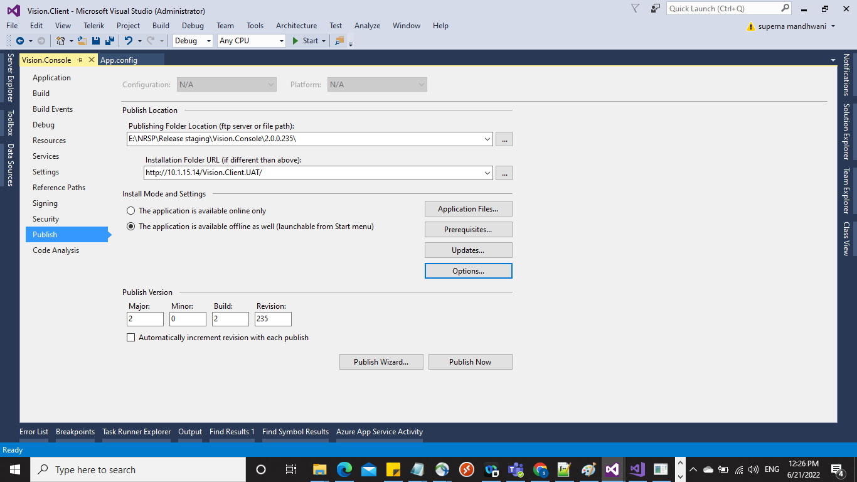
- Specify Product Name (As per application name deployed on server)
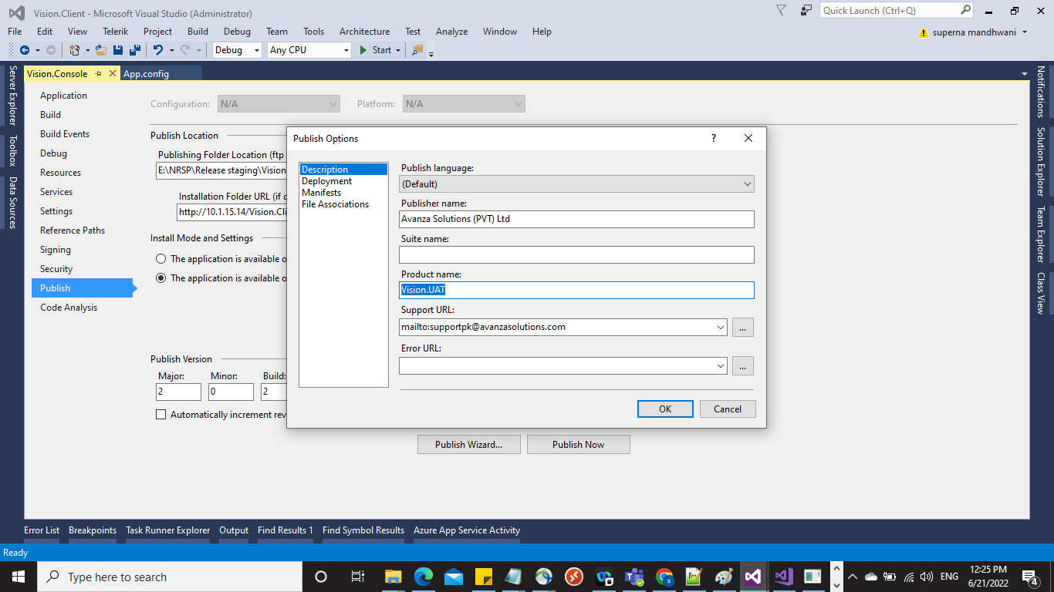
- Click on Publish Now
